Create authentication service that returns JWT

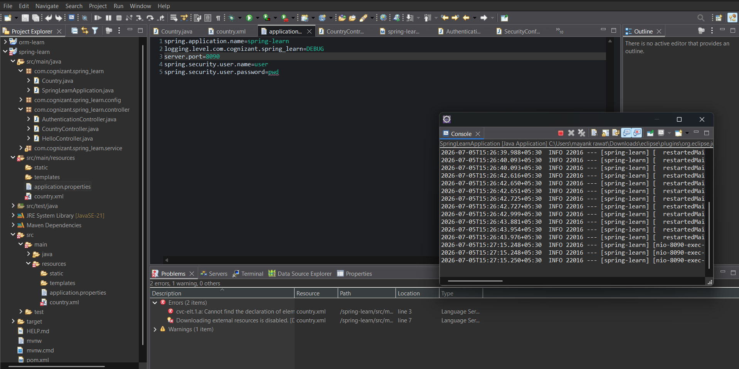
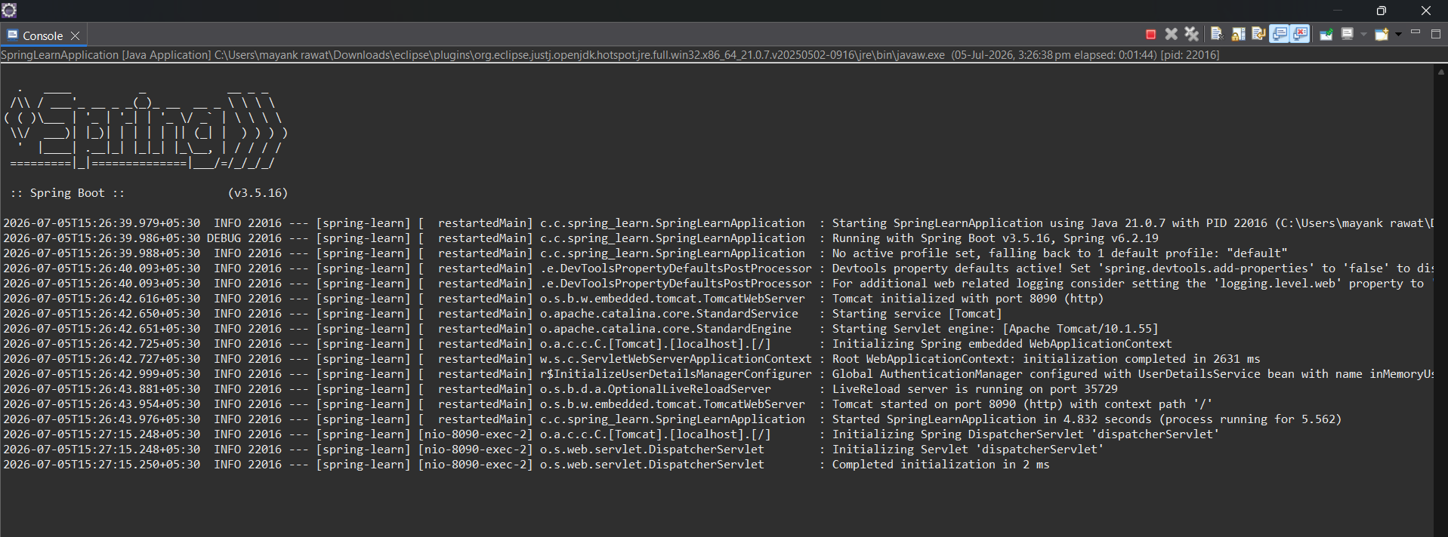
After adding id and password

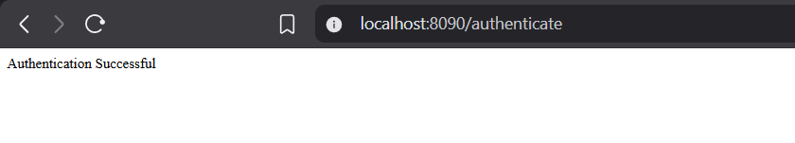

AuthenticationController.java
package com.cognizant.spring_learn.controller;
import org.springframework.web.bind.annotation.GetMapping;
import org.springframework.web.bind.annotation.RestController;
@RestController
public class AuthenticationController {
@GetMapping("/authenticate")
public String authenticate() {
return "Authentication Successful";
}
}

SpringLearnApplication.java
package com.cognizant.spring_learn;
import org.slf4j.Logger;
import org.slf4j.LoggerFactory;
import org.springframework.boot.SpringApplication;
import org.springframework.boot.autoconfigure.SpringBootApplication;
import org.springframework.context.ApplicationContext;
import org.springframework.context.support.ClassPathXmlApplicationContext;
@SpringBootApplication
public class SpringLearnApplication {
private static final Logger LOGGER =
LoggerFactory.getLogger(SpringLearnApplication.class);
public static void main(String[] args) {
SpringApplication.run(SpringLearnApplication.class, args);
//displayCountry();
}
public static void displayCountry() {
ApplicationContext context =
new ClassPathXmlApplicationContext("country.xml");
Country country =
context.getBean("country", Country.class);
LOGGER.debug("Country : {}", country.toString());
((ClassPathXmlApplicationContext) context).close();
}
}

Application.properties
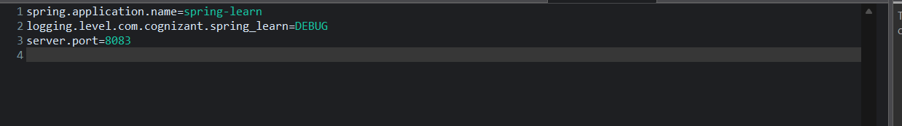

HelloController.java
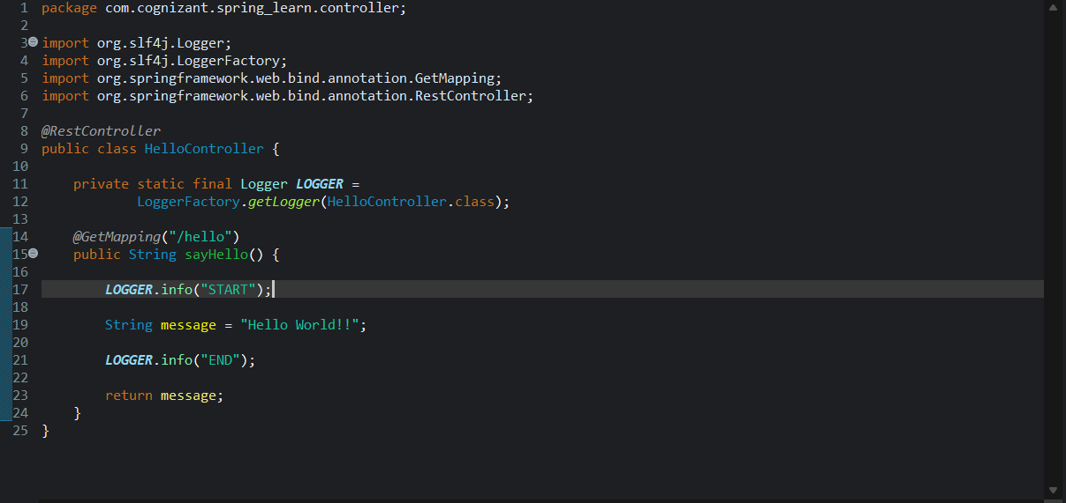

CountryController.java
package com.cognizant.spring_learn.controller;
import org.springframework.beans.factory.annotation.Autowired;
import org.springframework.web.bind.annotation.GetMapping;
import org.springframework.web.bind.annotation.PathVariable;
import org.springframework.web.bind.annotation.RestController;
import com.cognizant.spring_learn.Country;
import com.cognizant.spring_learn.service.CountryService;
@RestController
public class CountryController {
@Autowired
private CountryService countryService;
@GetMapping("/countries/{code}")
public Country getCountry(@PathVariable String code) {
return countryService.getCountry(code);
}
}

SecurityConfig.java

Country.xml
<?xml version="1.0" encoding="UTF-8"?>
<beans xmlns="http://www.springframework.org/schema/beans"
xmlns:xsi="http://www.w3.org/2001/XMLSchema-instance"
xsi:schemaLocation="
http://www.springframework.org/schema/beans
https://www.springframework.org/schema/beans/spring-beans.xsd">
<bean id="countryList" class="java.util.ArrayList">
<constructor-arg>
<list>
<bean class="com.cognizant.spring_learn.Country">
<property name="code" value="IN"/>
<property name="name" value="India"/>
</bean>
<bean class="com.cognizant.spring_learn.Country">
<property name="code" value="US"/>
<property name="name" value="United States"/>
</bean>
<bean class="com.cognizant.spring_learn.Country">
<property name="code" value="DE"/>
<property name="name" value="Germany"/>
</bean>
<bean class="com.cognizant.spring_learn.Country">
<property name="code" value="JP"/>
<property name="name" value="Japan"/>
</bean>
</list>
</constructor-arg>
</bean>
</beans>

